LETS UPGRADE –LINUX ADMINISTERATION

ASSIGNMENT 1

By

Rasika kulkarni

**1. Create a blank file named "myfile"**

**2. Open "myfile" in vi editor**

**3. Write your name, address, email id, phone number and blood group in 5 different lines**

**4. Build one single expression to see the line with your name and blood group in myfile.**

**Q1. Create a blank file named "myfile".**

Ans:- creating an empty file named myfile by using Touch command.

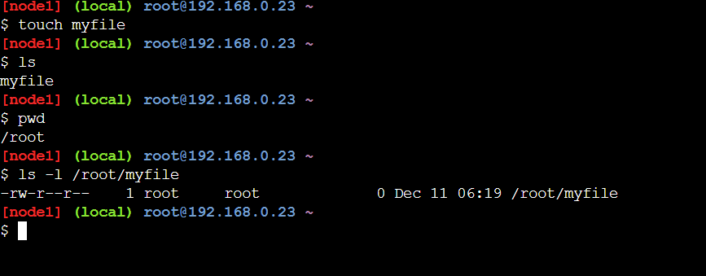

**2. Open "myfile" in vi editor.**



**3. Write your name, address, email id, phone number and blood group in 5 different lines.**

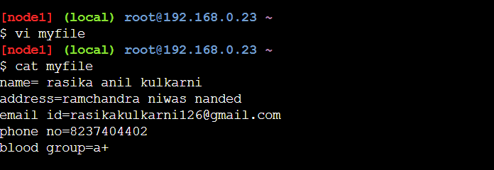

**4. Build one single expression to see the line with your name and blood group in myfile.**

